IMEC Practical Test I

- A computer program generates all four-letter code words that can be formed by using alphabets I, M, E, and C. When all these words are categorized according to the alphabets order, it can be listed ass follows.
CEIM, CEMI, CIEM, CIME, ….
At place, the word IMEC appears. Find the value of n.

A. 15 B. 16 C. 20 D. 24 E. Other

- In which figure, will the total number of pentagons be 210.
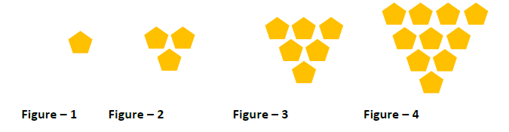

A. 19 B. 20 C. 21 D. 22 E. Other

- Find the next:
A. 108 B. 192 C. 12025 D. 10202 E. Other
- Solve

A. 2021 B. 2022 C. 2024 D. 2025 E. Other

- Find the sum:

A. 234 B. 123 C. 603 D. 700 E. Other

- Find the missing number

A. 10 B. 20 C. 5 D. 4 E. Other

- Solve

A. 504 B. 1 C. 120 D. 2 E. Other

- Study how the following machine work

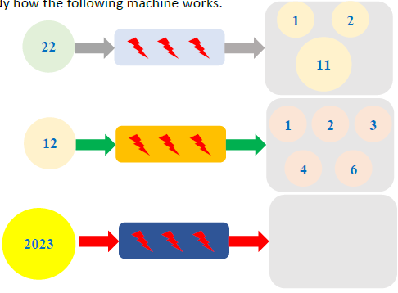

If 2023 is into the following machine, find the sum of all the numbers that will be outputs inside the grey rectangle.

A. 144 B. 314 C. 433 D. 2456 E. Other

- What is the value of in the figure below
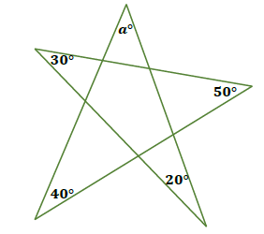

A. B. C. D. E. Other

- The two solids in the figure have the same volume. How large is x?
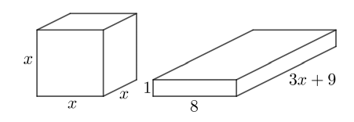

- 3 B. 4 C. 5 D. 6 E. Other

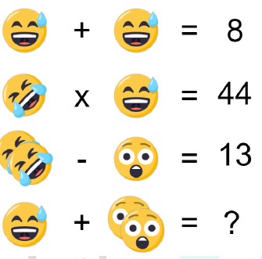
- Solve

A. 64 B. 74 C. 84 D. 50 E. Other

- Find


A. 56 B. 62 C. 21 D. 52 E. Other

- Solve

, Therefore

A. 44 B. 52 C. 63 D. 66 E. Other

- There are 100 chickens and rabbits on a farm. The total number of legs of the chickens is 80 more than the total number of legs of the rabbits. How many Rabbits are there?

A. 20 B. 10 C. 1 D. 5 E. Other

- Each worker in a factory can produce 8 shirts or 14 pairs of pants. One suit consists of 1 shirt and 1 pair of pants. How many suits can 154 workers produce in a day?

A. 784 B. 654 C. 384 D. 574 E. Other

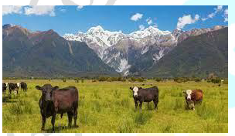
- A famer prepared a pile of grass for his herd. The pile of grass was enough to feed 3 cows and 6 goats for 15 days, or 4 cows and 10 days. For how many days could the pile of grass feed 4 cows and 4 goats.

A. 12 B. 13 C. 14 D. 15 E. Other

